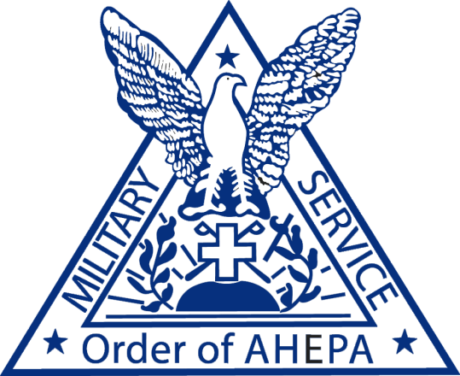

Honoring our veteran



CHAPTER PRESIDENT |  | E. Chris Kaitson  AHEPA Supreme president

“The Mission of the Order of AHEPA Veterans Committee is to archive
and recognize all veterans of the Order and Hellenic community
through sound communication and publication. Furthermore, to
conduct fund raising and philanthropic outreach through a cohesive, limited, yet well defined activity that reflects well on the Order of AHEPA
and brings credit to the organization at large”
